Camp II
Learn the most advanced interleaved retrieval methods in our program.
Overview and recommendations
Key dimensions | Retrieval, self-management
Recommended pace | 3 to 4 hours of theory across 2 weeks
Recommended practice | Most learners see best results with consistent practice across 3 to 4 weeks.
Progression tips | This stage includes advanced retrieval techniques that are technically some of the most difficult in the entire program, especially "WPW". Retrieval and self-management techniques also inherently take longer to practice as they require a spacing interval. Although it can take months to master the techniques in this stage, most learners can progress to the next stage after 3 to 4 weeks of diligent practice.
How this stage helps you
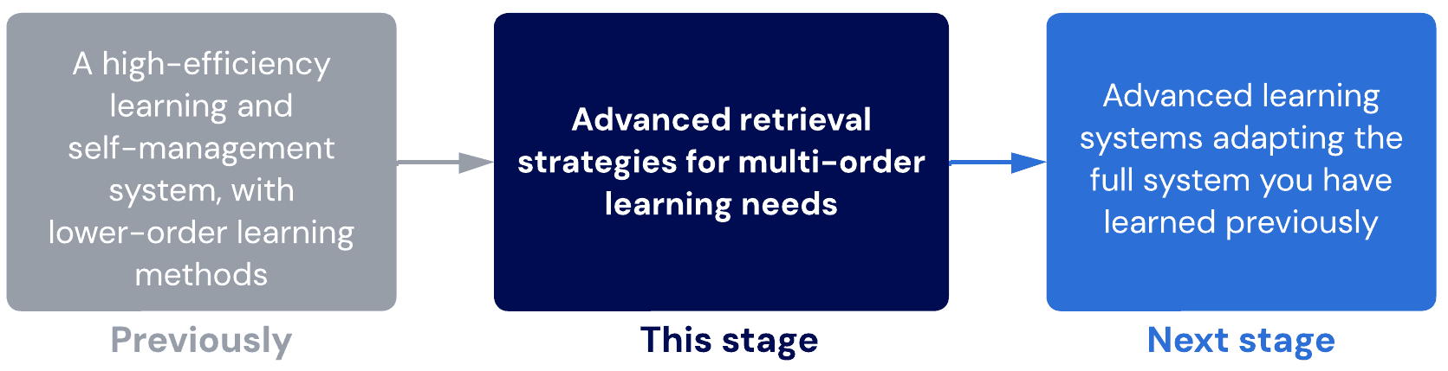
Lessons
- Revision strategy
Audit your revision strategy to ensure there are no gaps or weaknesses in your system.
Sub-lessons
- Preparing for revision
- Revision pitfalls
- Revision – time
- Effective revision
- Reconstruction
Learn about reconstruction vs. recall and how it can improve your retrieval practice.
- WPW
Learn one of the most effective but cognitively advanced retrieval methods you can use.
Sub-lessons
- Whole-part-whole technique
- Whole-part-whole tips
- WPW example dissection: Economics
- WPW example dissection: Equilibrium
- WPW example dissection: Electromagnetism
- WPW example dissection: Biodiversity
- Advanced time management skills
Overcome the busiest pressures with our most advanced time management methods.
Sub-lessons
- Task management
- Decisional delays
- Attention management
- Final checkpoint – Camp 2
Evaluate your level before moving to Summit, the final stage!

- Revision strategy
In this Stage…
The following techniques are new.
Technique | Rationale
Revision strategy | A long-awaited update to your basic revision strategy.
Whole-part-whole (WPW) reteaching | An advanced, extremely effective revision strategy. It is nearly impossible for untrained students to perform this correctly.
Advanced time-management strategies | An advanced method of time management that Dr Justin uses on a daily basis. This system allowed him to operate 4 businesses, dance competitively, powerlift competitively and maintain a relationship while being a full-time medical doctor.
The following techniques have been replaced or upgraded.
Prior Technique | Replaced by…
Revision basics | Revision strategy + WPW reteaching
Scheduling basics | Advanced time-management skills
All other techniques from Camp I should continue to be used.
Sub-lessons
- Preparing for revision
- Revision pitfalls
- Revision – time
- Effective revision

- Preparing for revision
We have covered the four layers of learning and the tools to learn each layer properly (including GRINDE maps, flashcards, and the modified method of loci).
The only thing left is a strong revision strategy to fill any gaps.
Before revising, you should quickly sweep through your course material to see if you’ve missed anything you need to learn. You can also use the modified method of loci to improve your mind map by replacing lists of information with drawings.

- Revision pitfalls
The nature of revision
Revision involves looking at the information you have learned and then finding and filling any gaps. A robust revision strategy will catch any small details you missed when learning the information, meaning you don’t need to worry too much about missing things!
Many students only revise by doing past papers or re-reading notes. Often, their strategies are passive and do not engage the appropriate levels of challenge that we introduced in the interleaving table.
Key principles for a safe revision strategy
- Interleave with different methods at different orders and types of knowledge.
- Use retrieval methods that are strategic for finding your gaps and filling them.
- Always utilise recall over recognition.
- Maximise the benefit from past papers using more active and elaborative methods, instead of passively solving and checking answers.
Alert
If you are unsure about which methods of retrieval are suitable for finding gaps or would help maximise the benefit from practice questions, we strongly recommend reviewing the previous recommended tasks around interleaved retrieval and the interleaving table.
At this point in the program, all of this should be a recap.
What defines a knowledge gap?
A knowledge gap is any missing information or relationship that is important and relevant. You can identify gaps by assessing and testing yourself. There are different kinds of gaps, explained below.
You struggle to identify the correct approach and strategy to solving a problem
This indicates a declarative knowledge gap on how concepts can be related to each other and their purpose/influences. This kind of gap is common among engineering, coding, physics, and maths where there is insufficient attention given to the conceptual network and excessive focus is on procedural repetition and practice.

You struggle to recall information
This indicates a broad retrieval gap that should be filled with deeper relational encoding or a lower-order memorisation method, depending on the type of information and the layer it belongs to. If a high volume of information is forgotten, the problem is almost always due to a suboptimal chunk structure. Evaluate your maps for waterfalling and spiderwebbing and ensure the chunks are intuitive. Beware of simple question and answer, which can undermine the inquiry process.

You struggle with consistently solving problems due to errors
This indicates a procedural knowledge gap caused by a lack of practice and execution-style interleaving. In some cases, the errors are due to conceptual/declarative knowledge misunderstandings.

You struggle to apply knowledge in different contexts or more nuanced settings
This indicates a higher-order knowledge gap caused by missing relationships.
Key principles for finding gaps
- Look for gaps - don't avoid your weaknesses
- Test at multiple orders
- Do not refer to answer sheets until you have created your own answer sheet through self-study first. Premature answer sheet checking often creates illusions of knowledge and is a common mistake.
- Remember that struggling to answer a question indicates a gap. Even if you get the question right, you might just have gotten lucky! Difficulty matters more than correctness.
- Revision – time

For more information about measuring your learning efficiency accurately, check out our article here.

How do you measure learning efficiency?
Skill development

The problem with efficiency
Most people think about learning efficiency as how much content you can cover in a learning session. For example, an efficient learner can cover 5 lectures in 2 hours.
However, this is very problematic for multiple reasons:
- It does not consider the retention of knowledge
- Extra time is spent relearning information that is forgotten
- It does not consider the quality of learning that occurred or the person's ability to perform and use their knowledge in different ways
Ultimately, thinking about efficiency as the "amount covered per session" is a useless metric.
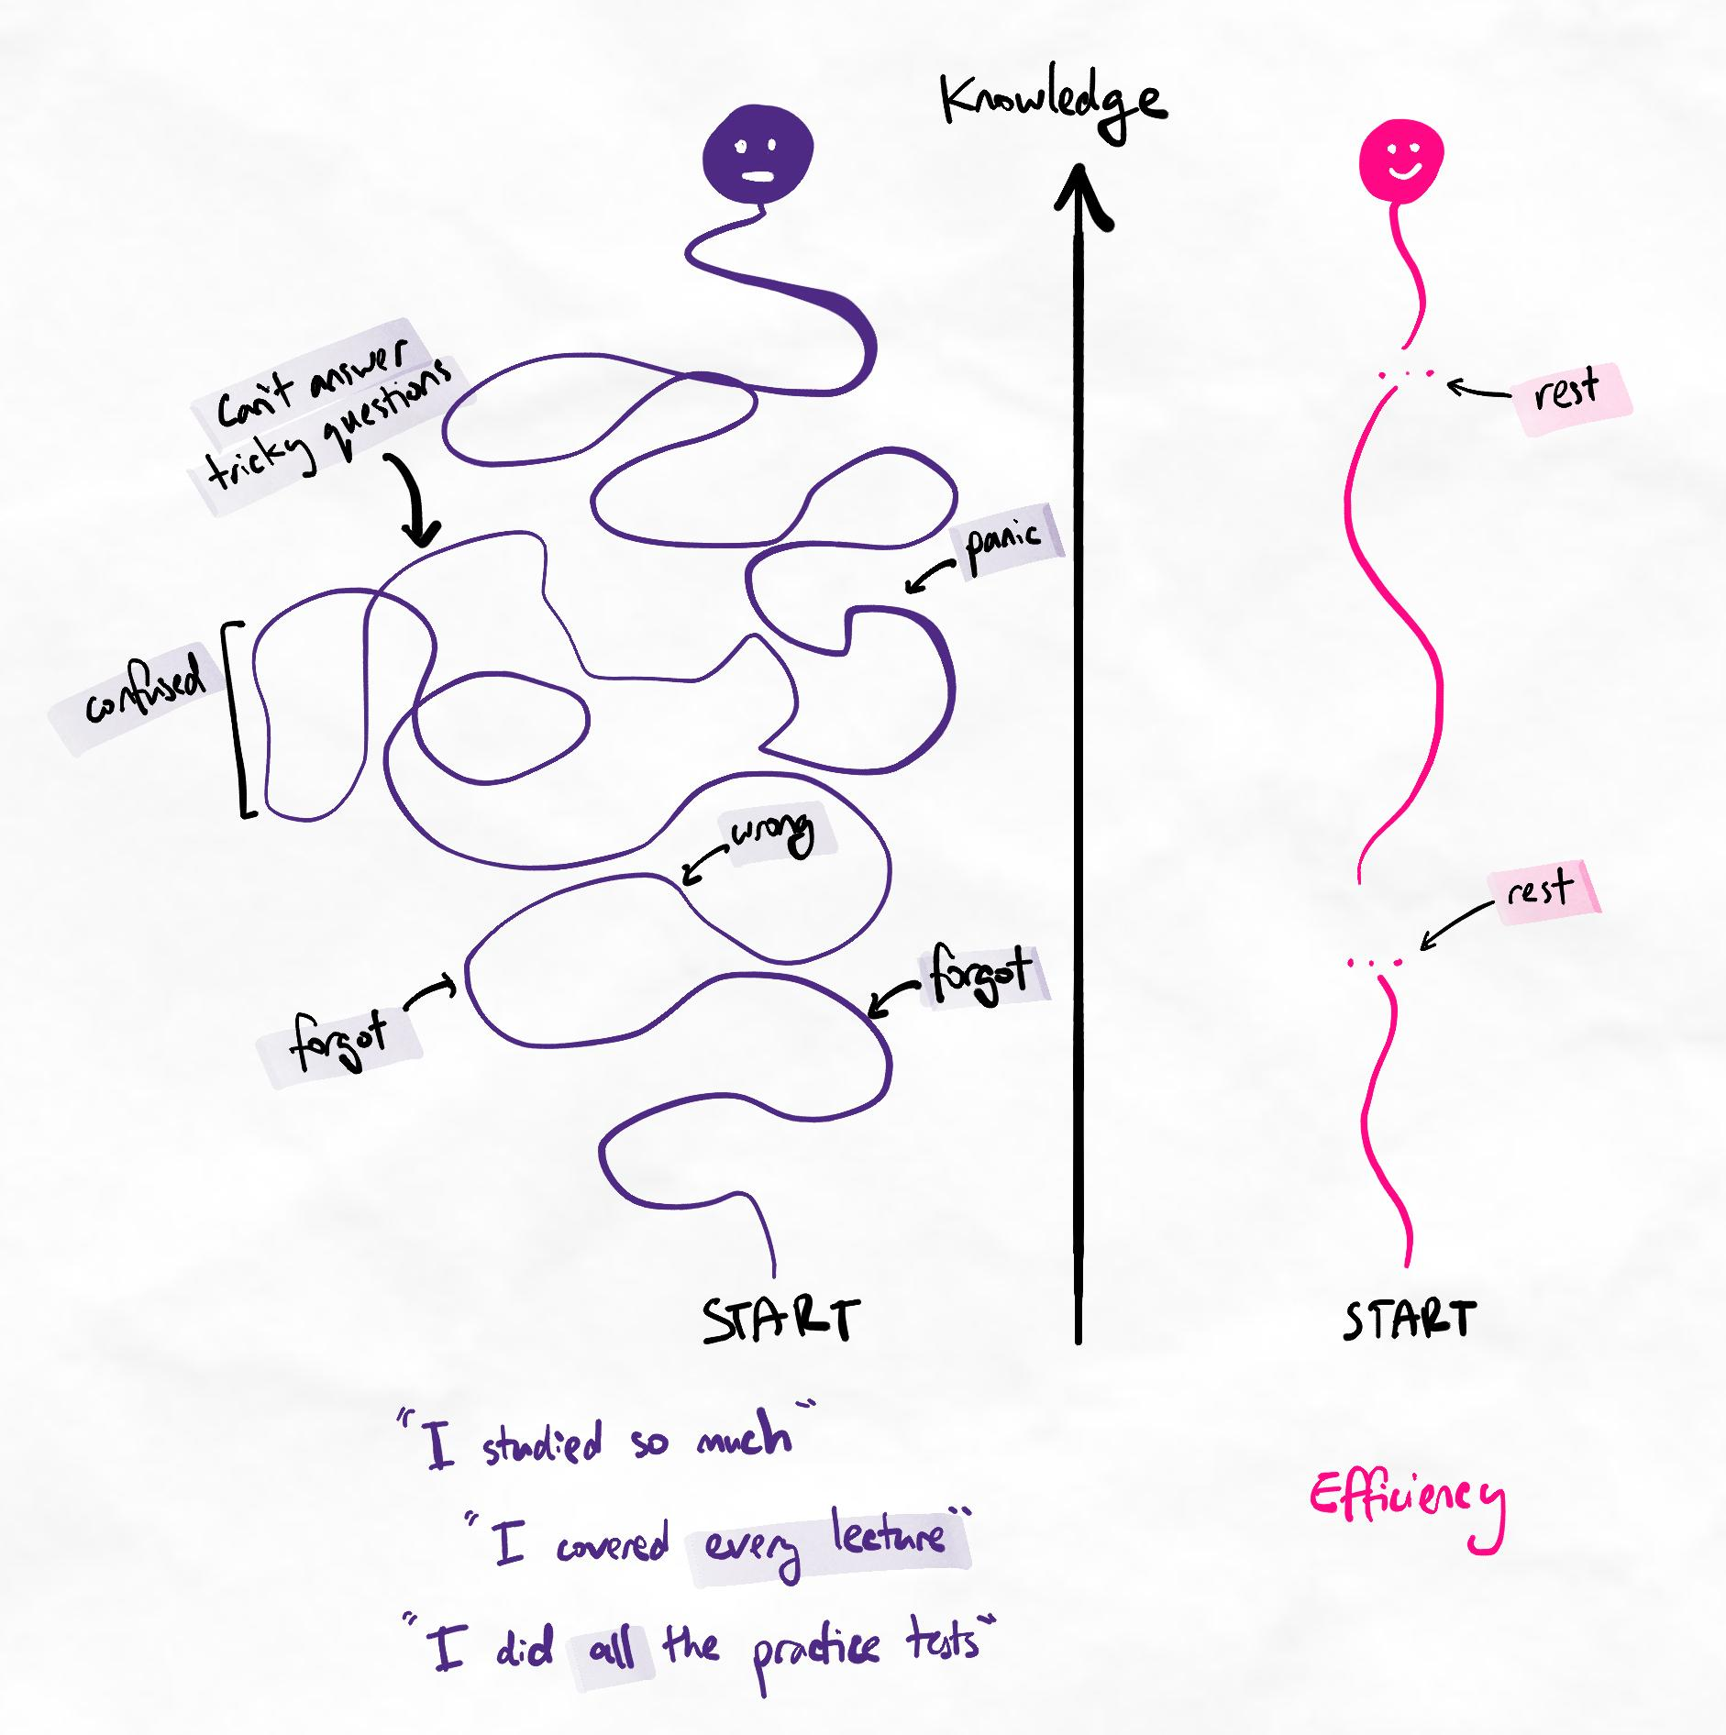Efficient learners focus on learning to high quality. Inefficient learners focus on "doing more".
The components of efficient learning
What we want to know is the amount of time it takes for a learner to gain high-quality, usable knowledge and retain this information for their purposes. Efficient learning can be summarised as:
- Achieving the necessary mastery of knowledge
- Having sufficient retention of this knowledge at each level of required mastery
- Being able to achieve the above in a short amount of time
The learning efficiency equation
Learning efficiency = Total mastery and retention over Total time spent learning
For example, we may say that an inefficient learner achieves 50% over 100 hours, while an efficient learner achieves 90% over 50 hours. We will explain what this means below.
Total mastery = average of all partial masteries
Partial mastery = retention per mastery level / required retention per mastery level
How to calculate the values
- Identify the highest and lowest required knowledge mastery levels. Refer to our article on "How to measure knowledge mastery".
- Assess your retention after one week (as a percentage) for each level. We use one week because our spacing intervals should allow for a one-week retrieval session. It can be extrapolated to the level of retention you may have for an assessment.
- Identify the retention you require for each level for your assessment.
- Calculate partial mastery by dividing your real retention after one week by the required retention.
- Calculate total mastery by taking the average of your partial masteries.
- Calculate the total time you spent on all learning and retrieval sessions for this subject (across however many weeks).
Example

Jeremy is studying for a second-year university economics exam.
- Knowledge mastery (highest): For his level, he is assessed at a maximum of level 4.
- Knowledge mastery (lowest): He is sometimes asked about specific fact recall, so he is assessed at a minimum of level 1.
After a couple of weeks of studying, Jeremy has found that his one-week retention is as follows:
Level | Retention | Required for assessment
1 | 60% | 80%
2 | 60% | 90%
3 | 50% | 70%
4 | 30% | 60%
By dividing retention by the percentage required for assessment, we can calculate the partial masteries:
Level | Retention | Required for assessment | Partial masteries
1 | 60% | 80% | 60%/80% = 75%
2 | 60% | 90% | 60%/90% = 67%
3 | 50% | 70% | 50%/70% = 71%
4 | 30% | 60% | 30%/60% = 50%
Simple summary
In words, this tells us that Jeremy has only reached 50% of the mastery and retention he needs for his assessment. On the other hand, he has reached 75% of his requirements for level 1 knowledge, such as fact recall.
To calculate his Total mastery, we simply average the value of all the partial masteries.
The average of 75%, 67%, 71%, and 50% is 66%. Therefore, Jeremy's Total mastery is 66%.
He has spent a total of 30 hours studying so far.
Therefore, we can say that Jeremy's learning efficiency is 66% over 30 hours.
Inefficient learners
When we complete this calculation for inefficient learners, we often find that as hours increase, the total mastery percentage does not increase much. For example, if Jeremy is not a very efficient learner, his 30 hours may increase to 60 while his mastery only improves to 76%.
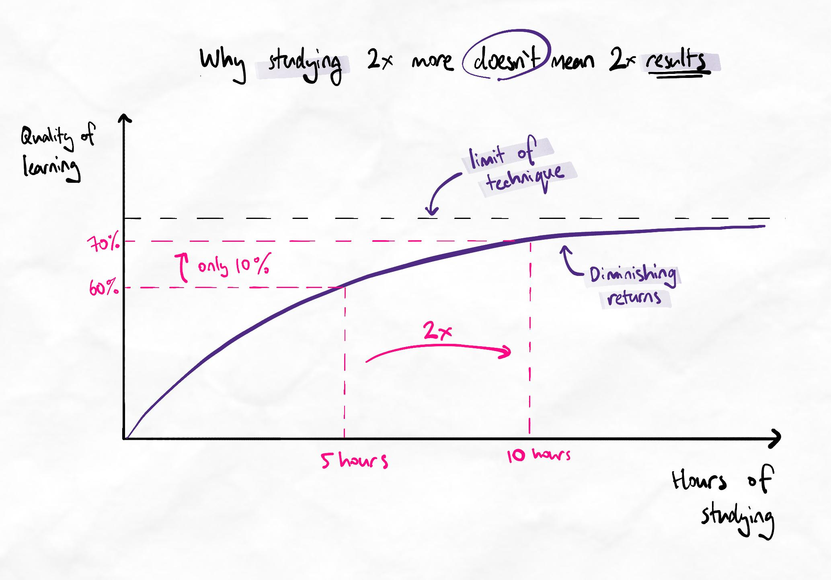If the methods are limited, more hours of studying produces smaller and smaller benefits.
By doubling his hours of studying, his results have only improved by 10%.
This is because certain methods are inherently limited.
Analogy
It's like trying to build a house with only a hammer. At first, you can build more and faster by spending more time building and swinging your hammer. However, at some point, there are certain tasks that you cannot achieve with only a hammer. It doesn't matter how much time is spent or how hard we swing it.
This is why efficient learners must use methods specifically to achieve certain mastery levels.
Key considerations
- Efficient learners can achieve a higher percentage in less time.
- More time does not necessary increase the percentage of achieved mastery and retention. In most cases, the rate of forgetting becomes so high with large volumes of learning that learners never reach 100% retention, especially at higher levels of mastery.
- The method of learning strongly dictates how easily higher levels of mastery can be attained. Some methods are frankly incompatible with achieving higher mastery, unless you have very high deep processing.
- Learning efficiency depends on the required level of mastery and retention. Lower requirements are easier to meet in less time.

Example values of efficiency for different learner scenarios
Learner type | Mastery profile | Time investment | Example values
Inefficient methods, low deep processing | Achieves lower levels. Struggles with higher levels. Retention generally low. | High due to excessive relearning. | 50% over 100 hours. Total mastery does not improve by much when hours increase.
Inefficient methods, high deep processing. | Achieves most levels of mastery. Retention low to moderate, depending on deep processing. | Moderate. | 70% over 50 hours. Total mastery may increase slowly with increase in hours.
Efficient methods, low deep processing | Achieves most levels but struggles with higher levels. Retention generally moderate. | Moderate to high. | 70% over 50 hours. Total mastery increases proportionally when hours increase.
Efficient methods, high deep processing | High achievement across all levels. Retention high. | Low | 90% over 30 hours. Total mastery increases proportionally when hours increase.

- Effective revision
Expanding-gap spaced repetition
Ensure that the gaps between your revision sessions are getting longer. Do at least one or two retrieval practice sessions in the first 10 days and continuously expand the gaps for all subsequent sessions.
Interleaving
It is inefficient to always practice under the same conditions. The brain learns much better by practising with slight variations each time.
Gap-seeking
Actively look for gaps. To do this, apply the Aim step again to the study material and your GRINDE map. You will see things in your GRINDE map that you don’t know well and can deliberately ask questions to explore your gaps in a more targeted way.
Note
This sublesson is a recap. You should already be applying all of this so far! If not, this is your cue to re-evaluate your system. If there are gaps in the basics of your revision strategy, the following lessons will become much more challenged than necessary.

- Reconstruction
About reconstruction
Reconstruction goes a step beyond recall. It involves not only recalling the information but also applying it to construct new and valid relationships.
This forces you to evaluate each piece of information critically (to see if your new relationships are accurate) while comparing and examining multiple chunks.
Key principle
Reconstruction works at the ‘Evaluate’ and ‘Create’ levels while also testing the lower orders.
In the next lesson, we will use a heavily reconstructive retrieval method.
Which is better?
Since reconstruction-based strategies tend to take longer, it is best to use a combination of reconstruction and recall during your revision. Some students may find 10% recall and 90% reconstruction efficient, while others may find 50% recall and 50% reconstruction more manageable.
In the long term, most students find it efficient to do more reconstruction in the earlier phase of their learning. This is because it allows more rapid and comprehensive gap-finding. Recall can be used in later phases to develop more detailed retrieval performance and mastery.

- WPW
Teaching to learn
It is not good to be dependent on a good teacher. By developing the skills to be your own best teacher, you will always be able to teach yourself!
This is where the Whole-Part-Whole (WPW) technique comes in. This technique is highly multi-order, covering all levels of retrieval in Bloom's revised taxonomy.
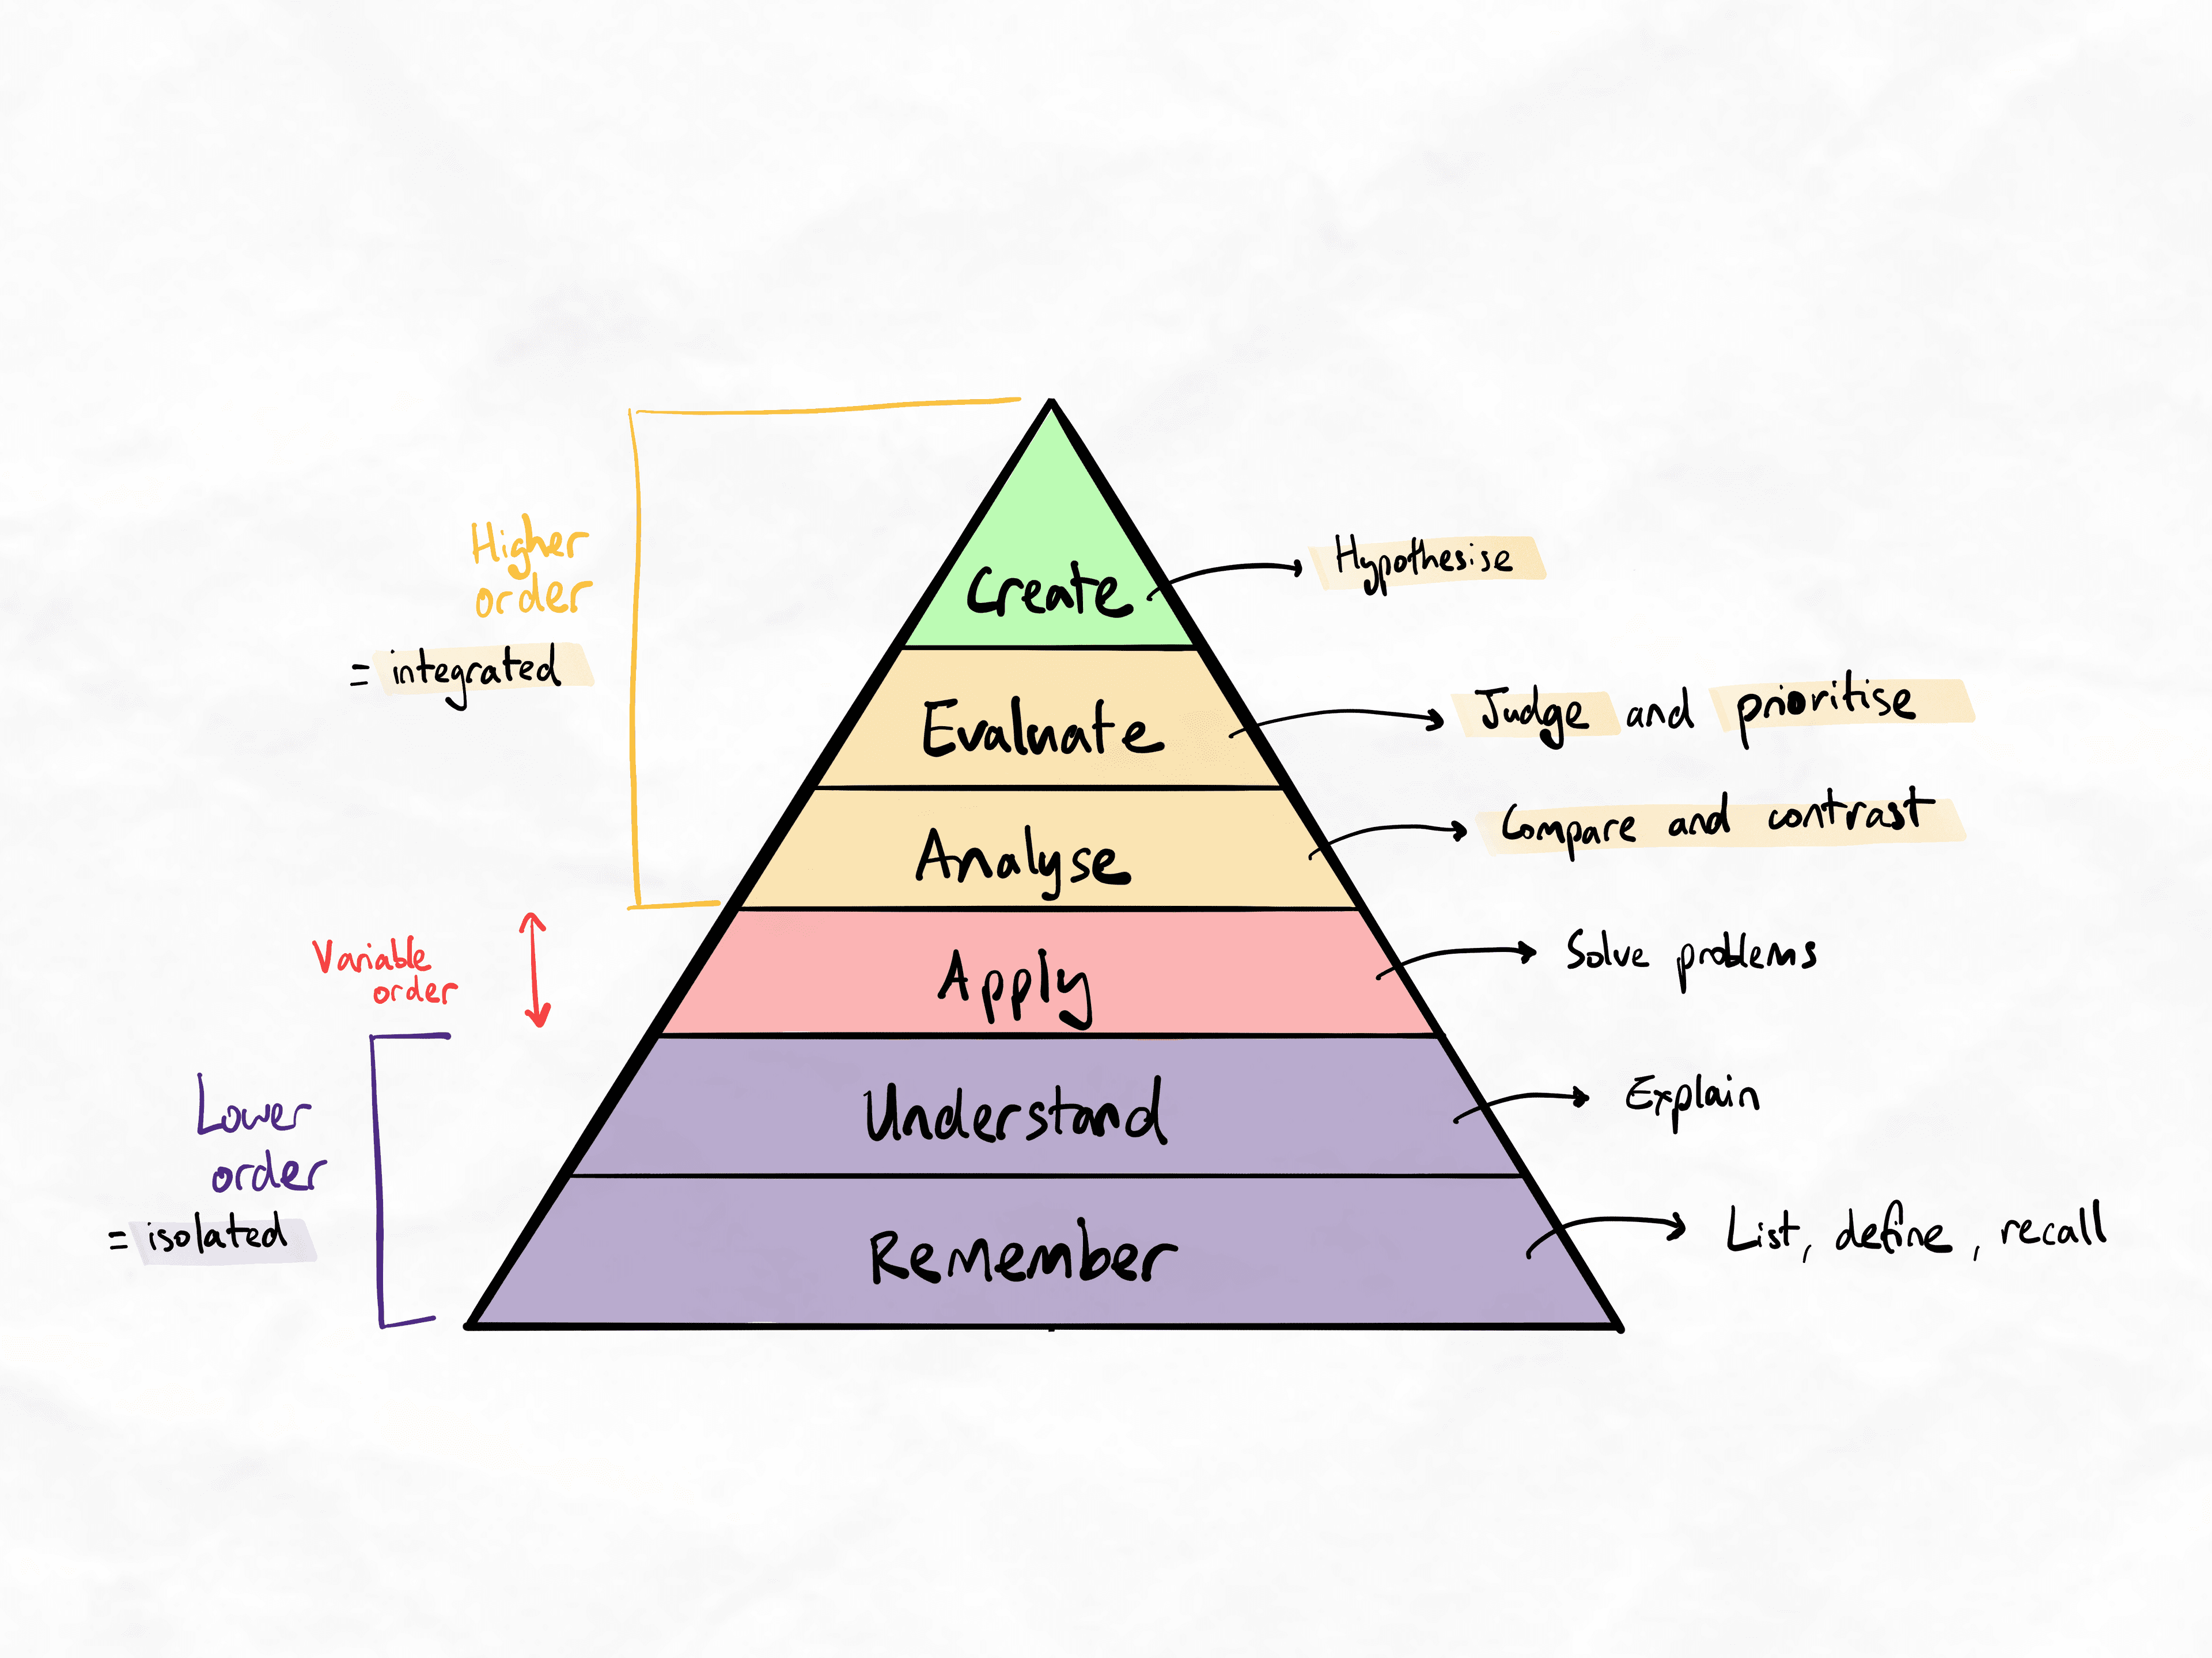Bloom's revised taxonomy (2001)
This multi-level coverage is what makes the technique so powerful. However, a significant amount of practice is required to perform this skill correctly. Even those who have a perfect level of competence with the methods in this program can take months to master WPW.

Research on good teacher dependency
The ‘good teacher reliance’ phenomenon is partially responsible for the fade-out effect. Read this summary article on how it affects people who receive lots of tutoring.

Research on the WPW technique
Malcolm Knowles outlines the WPW model in his book, ‘The Adult Learner: The Definitive Classic in Adult Education and Human Resource Development’. This is a recommended read for educators.
Barradell, Sarah, and Mary Kennedy-Jones. “Threshold Concepts, Student Learning and Curriculum: Making Connections between Theory and Practice.” Innovations in Education & Teaching International, vol. 52, no. 5, Oct. 2015, pp. 536–545. EBSCOhost, doi:10.1080/14703297.2013.866592.
Mowling, Claire M., and Brent Heidorn. “Every Shot Counts: Rallying Around Traditional Practices Strategies.” Strategies (08924562), vol. 26, no. 2, Mar. 2013, pp. 30–36. EBSCOhost, doi:10.1080/08924562.2013.764804.

High-volume retrieval practice (HVRP)
The WPW reteaching strategy is an example of high volume retrieval practice (HVRP).
This is an excellent approach during the early to mid stages of revision as it allows you to catch mistakes and target weaknesses quickly. It covers the topic very comprehensively, including relationships and specific details. Another example of HVRP is brain dumps. However, we have found this method to be less effective at testing relationships and conceptual understanding.
We recommend using HVRP as part of your spaced retrieval. This will help prepare you to use your knowledge for exams, essays and problem-solving.
Implementing HVRP
Schedule HVRP for your end-of-week or 2-week revision session. This way, your subsequent revision sessions will be more targeted. Below is an example of what your learning schedule might look like.
Timing | Activity
Before class/lecture (e.g., the weekend before or even weeks in advance) | Prestudy with inquiry-based learning via the BHS, creating at least a basic mind map up to layers 1 or 2 (if not layer 3) of learning.
During class/lecture | Consolidate layers 1, 2 and 3.  For subjects like Maths or Physics, use this time to practice applying techniques and using the information to solve problems.
Same day after class | Consolidate and add layer 4.  Skin your mind maps and create flashcards (and potentially test questions) for yourself.
Mid-week (only necessary if you are studying a high volume of material every week) | HVRP using WPW
End of the week | HVRP using WPW. If you already did this mid-week, do it for the new content you’ve covered since then.  For additional revision, answer the test questions you created (or share them with your study group).
Approximately 3 to 4 weeks later, and then again before the test or exam (if you have time) | HVRP via brain dump (linear or mind map) and practice papers.
You should consistently complete your flashcards daily using discrete pockets of available time via microlearning. Flashcards should not need their own scheduled session.

Table of contents
Sublesson
- Whole-part-whole technique
- Whole-part-whole tips
- WPW example dissection: Economics
- WPW example dissection: Equilibrium
- WPW example dissection: Electromagnetism
- WPW example dissection: Biodiversity

- Whole-part-whole technique
About Whole-Part-Whole (WPW)
The WPW technique involves looking at the topic as a whole, breaking it down into parts, and then returning to it as a whole.
It challenges your higher-order structures and clarity of prioritised relationships (ability to explain the whole clearly), the strength of relationships between layers (ability to move into parts and back into whole smoothly), and recall of detailed information (ability to explain each part accurately).
Meta-checklist
This table outlines how using this technique can feel and what these feelings mean at a cognitive level. Refer to this to ensure you understand the technique’s purpose and improve your metacognition. Connecting your emotional experience with the cognitive processes of learning can help you make fine-tuned adjustments and solve any issues.
How it can feel | Cognitive outcomes
It is very slow to teach, and you become hyper-aware of how you are speaking or the points you are choosing to explain next. | It forces a deep, multi-order evaluation of your knowledge structure. Your mental schema is being tested against higher-order criteria like “What makes the most sense?” and “Why is this important?”
You may feel anxious because you are frequently finding gaps in your knowledge. | This is a good thing! It allows you to identify gaps that may have been hidden by the illusion of explanatory depth.

- Whole-part-whole tips
Tips to execute WPW correctly
- Use reverse explanations.
- Always look for big-picture relevance.
- Don’t get locked into the way you taught it or learned it the first time. The ideal WPW flow may not be the same as your GRINDE map layers.
- Teach based on your memory/recall.
- Doodle a mind map as you are teaching.
- Speak out loud to slow yourself down. Don’t rush.
- Give yourself at least 3 days after finishing your GRINDE map.
- Use full recall to find gaps, then revise them to perfect your recall.
- If you struggle at first, keep trying. This means you are finding gaps.
General teaching flow
WPW teaching should follow two stages.
Stage 1: Layman's terms
Layman’s terms refer to common terminology that most people can understand, even without prior knowledge of the topic.
There are four parts to this stage. You should cover them in order, using only layman’s terms (no terminology):
- Explain what the topic is generally about (big picture).
- Explain why this is important to know.
- Explain how the topic can be divided into major components.
- Explain how the components relate to each other.
Once you have covered these four parts, move on to Stage 2.
This stage tests our understanding of concepts and relationships at the first and second layers of learning. This is good for protecting yourself against conceptual questions, difficult short-answer questions and curveball questions in exams.
By the end of this stage, the “listener” should have a solid conceptual understanding of the overall topic, why it is important, what its major components are, and how those components relate to each other.
Stage 2: Technical explanation
This stage involves introducing terminology.
There are two parts to this stage:
- Add technical terminology to the components you have explained. (This is known as labelling.)
- Using the terminology, explain each component in full detail. (This is known as technical elaboration.)
Ineffective teaching introduces the terminology first and teaches the definition and explanation later. By forcing yourself to explain the topic without relying on the terminology, you challenge your understanding of the concepts and relationships.
During the technical explanation, you must recall details and specific information. It protects us against detail-oriented questions, definitions and pure-recall questions.
By the end of this stage, they should know the technical names of concepts and components and be able to make sense of the details.
WPW mini quiz
Question 1
You're doing WPW correctly if…
All the key terminology has been neatly presented and listed out at the beginning of the teaching so that students know all the terminology and keywords they will need to learn.
The details are very accurate and precise. All the facts have been laid out comprehensively.
The upper levels of your teaching (i.e. the wholes) are simple enough that a 10-year-old could understand it easily.
Ans: The upper levels of your teaching (i.e. the wholes) are simple enough that a 10-year-old could understand it easily.
You're doing WPW correctly if…
You don't waste time talking about obvious relationships and concepts, instead focusing most of your time and attention on the most difficult processes and details that need to be elaborated.
You spend lots of time talking about why concepts exist and interact with each other the way that they do.
You focus on clarifying what different concepts mean so that the imaginary student is clear on definitions.
Ans: You spend lots of time talking about why concepts exist and interact with each other the way that they do.
You're doing WPW correctly if…
Terminology is introduced, then explained, in that order. This ensures the student knows what it is called and what the definition or meaning is.
New terminology and discipline-specific details are introduced relatively late in the teaching once it has been explained with layman's terms.
Details are evenly distributed throughout the entire teaching session so that neither you nor the student forgets which details to memorise and which concept they are attached to.
Ans: New terminology and discipline-specific details are introduced relatively late in the teaching once it has been explained with layman's terms.
You're doing WPW correctly if…
You identify gaps in your knowledge because you struggle to explain it simply, navigate from big picture to smaller details fluently, or recall the specific details within the parts. When this happens, you look at your notes or dive deeper into the topic to gain clarity and re-encode.
You maintain your fluency of teaching by referring to your notes and resources as you go so that your teaching flow is not disrupted (much like how you may teach a real class).
You maintain your fluency by skipping over parts you struggle with so that your teaching flow remains smooth. Gaps are filled by using this technique repeatedly while skipping over fewer parts with each attempt.
Ans: You identify gaps in your knowledge because you struggle to explain it simply, navigate from big picture to smaller details fluently, or recall the specific details within the parts. When this happens, you look at your notes or dive deeper into the topic to gain clarity and re-encode.

- WPW example dissection: Economics
WPW dissection: Economics
Key principles
- Make sure you are using reverse explanations instead of terminology crutching.
- Do as much as possible from memory. You want to test your retrieval, not your short-term memory or ability to read a mind map.
Terminology crutching is the most common mistake learners make. It makes the WPW process significantly easier, but by removing desirable difficulty.
Tip
WPW is a great technique to use for your end-of-week revision. It’s both broad and detailed, covering a vast scope of information and multiple forms of interleaving. It helps you to target your weaknesses quickly and efficiently.

- WPW example dissection – equilibrium
Key principles
- Focus on continually building relevance and relating information to its importance in the big picture.
- Do a reverse explanation for why the entire topic is important. This can help you to bridge into your components and major chunks more naturally.
Alert
While doing WPW, you may find that your most fundamental logical flow differs from your original logic layer. This isn't always a problem, but you should evaluate whether your initial chunking was as intuitive as possible. WPW may be the first time chunks are actively challenged – especially in topics with more "obvious" chunk structures.
Difficulty in fluently explaining the importance of topics or concepts may be a sign that your chunks were information-based rather than importance or logic-based.

- WPW example dissection – electromagnetism
Key principles
- Stay concise. Lack of conciseness can be due to a lack of clarity on how to communicate the importance of something. This leads to over-explanation and difficulties in smoothly transitioning to more detailed parts.
- Do not teach to the pen. The pace of teaching should not be limited by the pace of the mindmap/drawing. This is a common mistake when first using this method.
Note that most of these mistakes are common in those first learning the WPW method, even with high levels of knowledge expertise.

- WPW example dissection – biodiversity
In this example, there is one main area of improvement and uncertainty on whether the depth of detail and breadth of the topic covered is sufficient. Could you hear it while listening to this student’s attempt yourself?
What mistakes in your own WPW attempts do you now recognise at this stage?

4.Advanced time management skills

Advanced time management
Good time management means we can make things work on the worst days. In the sublessons below, we will build on your unconscious competence with all the earlier time and task management systems to implement more advanced self-management methods.

Table of contents
Sublesson
- Task management
- Decisional delays
- Attention management
- Task management
In addition to the Priority 0+1 system...
Use the following methods to enhance your task management ability.
- 2-minute rule: Straight-away complete tasks that you can finish within 2 minutes.
- Eat the Frog: First do the tasks that you don’t want to do.
- Manage dependencies: Clear bottlenecks by identifying tasks that future tasks depend on. This often involves developing skills or working with others. The task may not appear to be a high priority at first but is important in enabling future tasks.
Recommended apps
We have compiled a list of recommended apps that our team has extensively experimented with and integrated into our personal productivity systems. View the list here.
Miscellaneous
The following apps are recommended by the iCanStudy team after extensive personal usage and integration.
Disclaimer
In some cases, we have contacted the app developers to ask for a discount for our members, for which we receive a small commission. Despite receiving hundreds of requests from app developers to feature and recommend their products through an affiliate link, we strictly never recommend any apps we have not personally used and endorse. Apps without a discount likely represent apps that did not provide any discount, which we recommend regardless.

Book guides and book summaries
We recommend Shortform as it has some of the industry's most useful, practical, accurate, and comprehensive book guides. It is useful as a book adjunct and to scope potential sources to explore more deeply.
We have negotiated a free trial and a 30% discount on annual plans for our members using our affiliate link here. This is the highest level of discount offered by Shortform anywhere.
Shortform takes our recommended spot over the popular Blinkist as we have noticed the summaries of Blinkist can be inaccurate, miss important principles, and misrepresent ideas. Although this does not happen often, we have observed this enough times to be wary of the summaries. In some cases, books that were phenomenal when read in full seem mediocre in the summary due to misrepresentation.
However, Blinkist has a much larger library than Shortform. Therefore, if your budget allows, you may also wish to utilise Blinkist if Shortform does not have your target book. Note that Shortform continues to add new books every week, and members can vote for new books to be added.

Task management and prioritisation
Asana, ClickUp, or Amazing Marvin
Amazing Marvin is extremely powerful and probably the most customisable and fully featured task management app on the market. However, it can be overwhelming for beginners.
For most people who want something simpler, Asana has a free plan that is excellent for task management and will meet most people's needs. ClickUp is an alternative to Asana and has a different workflow and user interface. Many people prefer ClickUp to Asana due to its more intuitive workflows, especially when working in teams.

Scheduling and time management
Google calendars is our recommended option for most people as it is compatible with virtually every app and service, while featuring a robust set of time management features.
For Android, Business Calendar 2 is a versatile and customisable app that utilises the widget space of Android phones effectively.
On Windows devices, OneCalendar can be a simple calendar integration app.
For iOS devices, the Google calendar app is usually sufficient.

"Second brain", idea collection, knowledge bank, reference database
Obsidian is arguably the best app on the market for second-brain relational databases and a "source of truth". It can be used for a wide variety of uses. However, it has a steeper learning curve than apps such as Notion, which are also perfectly suitable for most people.
For those willing to learn and invest time in setting up their knowledge base, we recommend Obsidian. For those wanting to get into it and do not have complex relational knowledge needs, Notion will be more than enough.

Creating focus and removing distractions
There are many apps and websites for removing distractions and improving focus. There are also many new apps being released all the time. This is a list of apps and sites we recommend in our experience. There may be newer and better solutions that we have not used yet.
Website blocking: BlockSite has the useful option to block its own settings page through password protection via someone else's email address. Focused Work is also a useful app for blocking apps on iOS that also includes work-rest timing. The creator of Focused Work implemented some recommendations from Dr. Justin Sung into their work-rest timing options.
Work-rest timing: Tide (on both Android and iOS). Many other apps do the same thing. Tide is not necessarily the best, but one that we have found adequate for most needs. Focused Work is another recommendation, as above.
White noise generation: Relaxio and White Noise Lite (on Android or iOS). These apps are useful because you can modulate the type of white noise to fit the type of distracting external noise you are trying to block out.
Mindfulness meditation and sleep: Calm consistently ranks highly on our recommendations due to their high level of instructional guidance and support for beginners and the diversity of guided and unguided meditation modes for more experienced people.

Habit tracking
Remente is our recommended app due to its wide variety of features and flexibility, though Fabulous is also a good option for beginners. We feel that Fabulous may be too rigid for more experienced habit-setters.

Freehand note-taking
Concepts is one recommended app that we have used extensively. It is available on all operating systems. The features can be overwhelming at first but the interface can be adjusted in the settings to remove the unnecessary features and create a simple note-taking experience. We have negotiated a 30-day free trial for our members here. We do not receive any remuneration or commission or this recommendation or if you use the link. The free trial is for your benefit only.
Squid is another recommended app for Android. It is one of our favourite note-taking apps across any operating system and is also much cheaper than Concepts.
FreeForm is also a suitable free solution (if you already own an iPad) as it comes bundled with iOS. It is more limited in creating realistic pen strokes (which reduces the readability and enjoyment of the app for some), but it is otherwise a versatile and highly functional alternative.
Many learners use OneNote for their note-taking. However, in our experience, OneNote's note-taking experience is vastly inferior to the other apps listed and alternatives should be sought if possible.

- Decisional delays
What are decisional delays?
Decisional delays are the time it takes to decide what to do next. Cutting this time out may potentially save you hours a day. Decisional delays also interrupt your flow state.
Decisional delays are harmful because...
- They are barriers to maintaining flow states. This has potentially game-changing impacts on overall productivity as each break in flow requires an average of 15 minutes to re-enter flow. This can easily contribute to over an hour of delays daily.
- They use limited cognitive resources on planning that can make you unnecessarily tired and unfocused.
- They provide minimal positive value. The extra processing time does not confer any meaningful advantage.
Identifying decisional delays
Follow these instructions to start becoming aware of how decisional delays affect you.
- Use a time-tracking app and track how you spend your time every day for around one week.
- Every time you break out of a deep work/flow state, end the task time tracking and restart it once you are re-entering a focused session.
- Compare the time you tracked to the schedule you set.
- Identify the amount of time that was spent between tasks that your schedule did not plan for and the number of flow breaks that occurred. Each flow break can create 10 to 15 minutes of cognitive disruption and "lost time".
- Using these numbers, you can estimate how much time and disruption is caused by decisional delays.
Note that simply tracking your time and becoming aware of decisional delays is an important first step towards solving them.
How to mitigate decisional delays
- Experiment with your schedule and task flow to batch planning and prioritisation at the beginning or end of each day to avoid the need for mid-day planning.
- Block distractions from focus zones so new decisions do not enter your radar while you are working.
- Create very clear and specific instructions for yourself during planning sessions so there is no doubt or need for decision-making when you are in execution mode.

- Attention management
About attention management
Attention Management is a system for optimising flow. Rather than prioritising the time of day, it prioritises maintaining flow states for as long as possible, particularly by bridging flow states between tasks.
Attention management can allow for extremely high levels of productivity that can appear superhuman to others. When used alongside refined prioritisation systems, it may be possible to increase your meaningful goal-oriented output by 10x compared to the normal person.
Key principles for attention management
- Train yourself to have a keen level of self-awareness at where your attention is and if it aligns with your intentions. You must self-regulate your actions to prevent yourself from straying into unintended tasks and activities.
- Maintain flow at all times. Do not worry about when you finish or start a task. Simply operate in deep flow, trusting that this produces the fastest possible output at high quality.
- Remove decisional delays throughout the day. Every decisional delay is a flow-breaker. You want to be as close as possible to a robot following a set of pre-programmed instructions.
- Optimise your environments ahead of time to remove the need for environmental optimisation during the day.
- Utilise work-rest timing with active relaxation and recovery via breathing techniques for as many rests as possible.
Note
You will be forced to break out of flow and attention management when there are scheduled events, such as meetings, appointments, classes, etc.
This is unavoidable, so you may wish to plan small reprioritisation sessions intermittently throughout the day, before and after these mandatory disruptions and events.
Common questions
How do we measure the success of our attention management?
In conventional time management, we measure productivity by our ability to achieve planned tasks within a set time period. However, this has its own limitations. What if you are at 60% efficiency and focus? What if you waste 20 minutes procrastinating? What if you get distracted so much that you only get 45 minutes of real work done?
With attention management, we measure success based on our ability to achieve a planned task (e.g. "study the 3rd unit of biology to an 80% level of depth”) and how long we were able to maintain flow. It prioritises the achievement of the task over the time it took, understanding that our performance during flow states is likely near our maximum pace anyway.

When is attention management not appropriate?
Attention management prioritises the achievement of the task over the time it took, understanding that our performance during flow states is likely near our maximum pace anyway.
This approach is not always the best. For example, when time-boxing tasks, what is more important is that we limit the time we spend on a task rather than the magnitude of output. This is one reason why attention management is an advanced skill that requires significant experience with conventional time and task management principles.

How do I schedule for a day with attention management?
With conventional time management, we may set a task like "study biology" for two hours. If the task takes longer, we may micromanage our time and reschedule other items or use pre-scheduled buffer time. If the task ends earlier, we risk introducing decisional delays in planning what to do with the unexpected extra time.
Of course, when there is not much to do with a relaxed workload, this is no problem. We can simply rest and take time off! However, these small delays can be stressful when under heavy workloads.
With attention management, we create more generic time blocks such as "study". Once we achieve the goal for quantity and depth of learning we wish to achieve, we simply move to the next priority item for studying. If there is no next priority item for studying, we can directly move on to the next task in our plan.
Often, we can use these small pockets to handle "non-urgent and important" tasks or "urgent but not important" tasks - both of which do not require task-level completion, but simply some level of time dedication. Microlearning might also be implemented.

What about the power of deadlines and Parkinson's law?
Parkinson’s Law says that any activity or task fills the time given to it. If an essay is due in two weeks, it takes two weeks. If it’s due in two days, it takes two days. The difference in quality is insignificant. This is why so many of us leave assignments to the last minute – we know we can do it, and the result will be much the same!
Read about Parkinson’s Law on Wikipedia.
Even though we are not keeping to time-based deadlines with attention management, Parkinson’s Law can still be applied to our advantage.
To create a Parkinson's Law effect, set an estimated time to complete your task and a timer. Your goal is to finish it in that time. If you finish early, move to the next task. If you finish late, then Parkinson’s Law wasn’t enough to boost your output anyway.
Note that timing every focus session can also create unnecessary stress and pressure which has a psychological toll. It can be useful when you want to push yourself, but it is not recommended as a regular tactic.

Are there any long-term benefits of attention management compared to conventional time management?
There are some significant benefits to using attention management on a regular basis:
- You develop a keener self-awareness of your attention vs. your intentions. This helps to notice procrastination, distractions, and drifting focus earlier, which allows for faster self-correction.
- It becomes easier to refocus and centre once distracted because you are constantly practising to bring your attention in alignment with intentions (almost like extended focus training).
- It becomes easier to enter flow states of deep focus and concentration that use energy and cognitive resources very efficiently.

5. Final checkpoint – Camp 2
General competence assessment
Feel free to proceed to Summit once you feel comfortable with the techniques from Camp II. Similarly to Camp I, as these lessons do not involve much cognitive retraining, you should be able to progress relatively smoothly.
Technique(s) | Level of Competency
Revision strategy | Able to use more effective revision principles easily and comfortably.
WPW Reteaching | Able to use the WPW accurately. This technique is so powerful that it is virtually guaranteed to detect your gaps. If this is not the case, there is a high chance of incorrect execution.
Attention management – advanced time management skills | Experience with using attention management to a level of conscious competency. Able to detect and identify when attention is wavering throughout the day and when there are hotspots of hidden wasted time.
Progress Check
Procrastination
On a scale of 1 to 10, how well do you manage procrastination?
1 is very poorly (you significantly struggle with procrastination). 10 is very well (you do not have problems with procrastination at all).
Learning
On a scale of 1 to 10, how efficient would you rate your learning ability?
1 is not at all efficient. 10 is very efficient (able to cover large volumes with high depth and retention in a short time).
Confidence
On a scale of 1 to 10, how confident are you to overcome learning challenges and reach your learning goals?
1 is extremely unconfident. 10 is extremely confident.
Learning
If you have had an assessment (e.g. an exam) in the last four weeks, what results did you achieve?
96 to 100%91 to 95%86 to 90%81 to 85%76 to 80%71 to 75%65 to 70%60 to 64%Below 60%No recent assessment
Compared to your baseline performance, how would you rate your most recent learning performance?
Significantly worse
Worse
Similar
Improved
Significantly improved
Baseline is considered your normal level before joining our program.
Your experience
Have you noticed any other benefits or improvements that were not mentioned in the questions above?
For example, improvements in mood, sleep, career development, free time, well-being, or employability.
This is optional.

